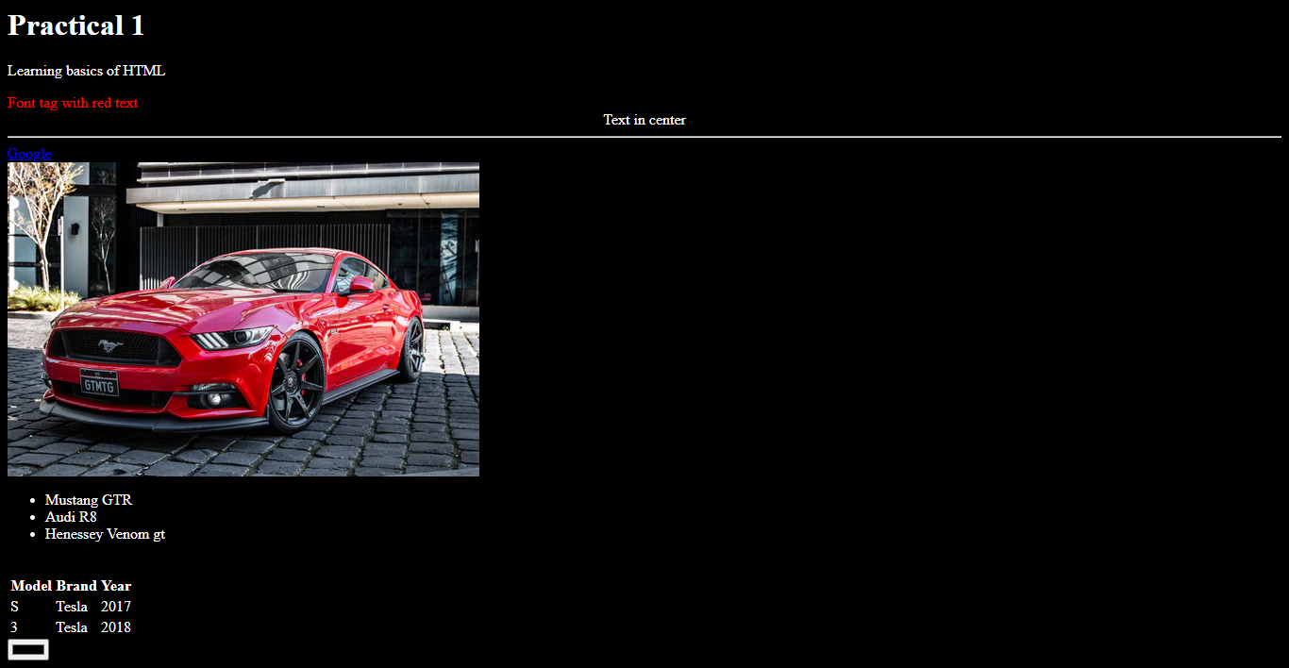

**Experiment No. 01**

**Title**: Design a web page using HTML tags.

**Batch: B2** **Roll No: 1914078 Experiment No:1**

**Aim:** To design a web page using HTML tags.

_________________________________________________________________

**Resources needed:** Notepad, any Web Browser and Internet._________________________________________________________________

**Theory:**

HyperText Markup Language, commonly referred to as HTML, is the standard markup language used to create web pages. HTML describes the structure of a website semantically along with cues for presentation, making it a markup language, rather than a programming language. HTML is the Web’s core language for creating documents and applications for everyone to use, anywhere.

The language is written in the form of HTML elements consisting of *tags* enclosed in angle brackets (like <html> ). Browsers do not display the HTML tags and scripts, but



use them to interpret the content of the page. HTML can embed scripts written in languages such as JavaScript which affect the behavior of HTML web pages. HTML can be edited by using professional HTML editors like: Microsoft WebMatrix, Sublime Text etc. However, for learning HTML we recommend a text editor like Notepad (PC) or TextEdit (Mac).

All HTML documents must start with a type declaration: **<!DOCTYPE html>**.

The HTML document itself begins with **<html>** and ends with **</html>**.

The visible part of the HTML document is between **<body>** and **</body>**.

**Sample HTML Document**

<!DOCTYPEhtml>

<html>

<head>

<title>PageTitle</title>

</head>

<body>

<h1>MyFirstHeading</h1>

<p>Myfirstparagraph.</p>

</body>

</html>

**HTML Tags**

The basic structure of an HTML document includes tags, which surround content and apply meaning to it. HTML tags are **keywords** (tag names) surrounded by **angle**

**brackets**.

**Attributes**

Tags can also have **attributes**, which are extra bits of information. Attributes appear inside the opening tag and their values sit inside quotation marks. They look something like <tag attribute="value">Margarine</tag>.

**Heading Tags**

Any document starts with a heading. HTML also has six levels of headings, which use the elements **<h1>, <h2>, <h3>, <h4>, <h5>, and <h6>**

*Format:* <h1> A Heading </h1>

**Body Tags**



The BODY tag surrounds all the content of your site. It allows you to set the look and feel of your site through **its attributes**.

The TEXT attribute allows you to set the color of the text:

|  |  |
| --- | --- |
| TEXT | <BODY TEXT=red> |

A page with that body will have red text.

The BGCOLOR attribute allows you to set the color of the background:

|  |  |
| --- | --- |
| BGCOLOR | <BODY BGCOLOR=blue> |

A page with that body will have a blue background.

The BACKGROUND attribute allows you to set an image as the background:

BACKGROUND <BODY BACKGROUND=monkey.jpg>

A page with that body will have a monkey for a background (if there was an image monkey.jpg in the same folder as it).

**Paragraph Tag**

The **<p>** tag offers a way to structure your text into different paragraphs. Each paragraph of text should go in between an opening <p> and a closing </p> tag

*Format:* <p> Some text </p>

**Font Tag**

The FONT tags allow you to set the color and size of a specific piece of text. Unlike the BODY tag the FONT tag only changes the text between the opening <FONT> and closing </FONT> tag.

The COLOR attribute allows you to set the color of the text:

COLOR

<FONT Color=red>Red Text </FONT>

The SIZE attribute allows you to set the size of the text:

SIZE

<FONT SIZE=6>Big Text </FONT>

**Line Break Tag**

The BR tag inserts a line break in the page.

*Format*: <br>Some text

**Centering Content**

The CENTER tags align the text between them in the center of the page *Format: <*center>Some text</center>



**Horizontal Lines**

Horizontal lines are used to visually break up sections of a document. The **<hr>**tag creates a line from the current position in the document to the right margin and breaks the line accordingly.

*Format:* <hr> Some text

**Links**

The A tag is used for links and anchors. If the link is to another page HREF is set equal to the URL of that page. If the NAME attribute is included instead of the HREF attribute then the A tag is being used to mark a spot in the page that can later be pointed to by a link.

*Format:* <a HREF=”a URL”>the link</a>

<a NAME=ANCHORNAME></a>

**Images**

This tag is used to insert an image into a page. The image is displayed where the <IMG> tag is inserted. The SRC tag tells the browser what image to insert. The width tag tells the browser what the dimensions of the image should be. If the dimensions of the image are different than what is given the browser stretches the image to make it fit. The height tag tells the browser what the dimensions of the image should be. If the dimensions of the image are different than what is given the browser stretches the image to make it fit. *Format:* <img src="photo.jpg">

**Tables**

The <table> tag must surround an entire table. It's attributes determine how the table looks.

|  |  |
| --- | --- |
|  |  |
|  |  |
| BORDER | This defines how big the borders of a table will be. |
|  |  |
| CELLPADDING | This defines how far from the edge of a cell the content in that cell will |
| be |
|  |  |
| CELLSPACING | This defines how far apart the cells of the table will be. |
|  |  |
| WIDTH | This defines the width of the table |
|  |  |
|  | This defines the background color of the table. If a color is specified in |
| BGCOLOR | the TR or TD tags BGCOLOR is ignored for that row, or cell |
|  | respectively. |
|  |  |

**List**

The LI tag creates a new element in an ordered or unordered list. The OL tags start and

end an ordered list. All of the elements in the list must be inside these two tags.

Format:

<OL>

<LI>element one.

<LI>element two.

</OL>

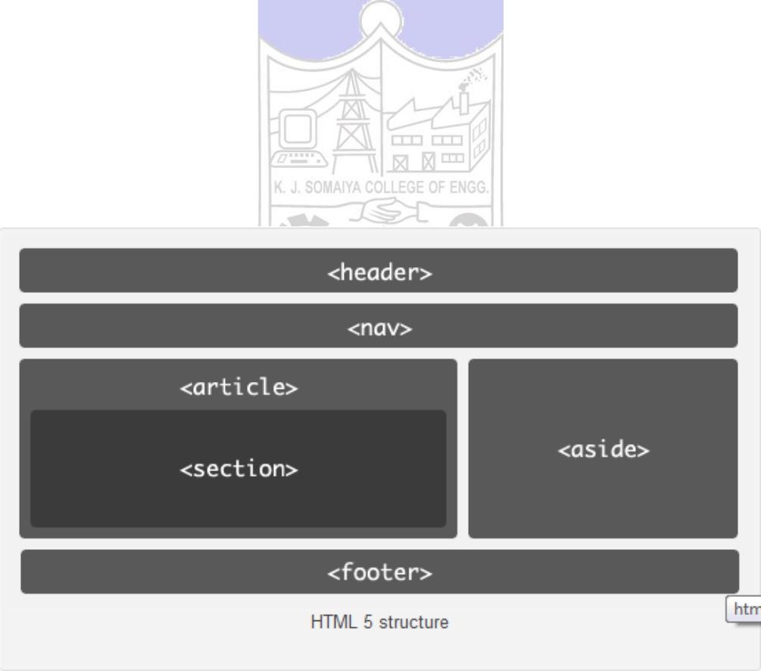

HTML 5 is latest version of HTML standard and is currently under development. HTML

is mark-up language – provides a way to describe structure of text and graphics on a

web page using its set of elements and attributes, deals with alignment of elements

on the web page too, derived from SGML

HTML 5.0 was started by World Wide Consortium (W3C) and the Web Hypertext Application Technology Working Group (WHATWG). HTML 5.0 reduces the need for external plug-ins.

Fig 1. HTML 5 structure

**New features in HTML5.0**

* New content specific Structural elements like article, footer, header, nav , section…etc
* New Form elements and attributes like calendar, date, time, email, url, search
* Canvas Element to draw graphic on a web page using JavaScript
* Video and Audio elements for media playback

* Geo Location

**Browser support:** HTML5 is not yet an official standard, and no browsers have fullHTML5 support. But all major browsers (Safari, Chrome, Firefox, Opera, Internet Explorer) continue to add new HTML5 features to their latest versions.

**Video Tag**

Video element is used for playing videos or movies. HTML 5 video element is a standard way to include video. You can play the video without the help of external plug-ins like flash player.

**Syntax:**

<video src="myvideo.mp4" controls=“controls”>

Your Browser wont support this tag

</video>

**Video Attributes:**

|  |  |  |  |  |
| --- | --- | --- | --- | --- |
|  |  |  |  |  |
| **Attributes** | **Value** |  | **Description** |  |
|  |  |  |  |  |
| src | url |  | Specify the location of the video file |  |
|  |  |  |  |  |
|  |  |  |  |  |
| height | pixels |  | Sets the height of the video player |  |
|  |  |  |  |  |
|  |  |  |  |  |
| width | pixels |  | Sets the width of the video player |  |
|  |  |  |  |  |
|  |  |  |  |  |



**Audio Tag**

Audio element is used for playing audio files.Audio element represents a audio or sound stream HTML 5 audio element is a standard way to include audio You can play the audio without the help of external plug-ins like flash player. Content can be given between the opening and closing of the audio tag. This content should not be shown by the user agents and is intended for the older browsers which do not support audio tag.

**Syntax:**

<audio src=“myvideo.mp3” controls=“controls”>

Your Browser wont support this tag

</audio>

1. src attribute is used to identify the media
2. controls attribute is used to specify whether or not to display audio controls.

**Audio attributes:**

**Attributes  Value**

src url

|  |  |
| --- | --- |
| controls | Boolean- any value sets this |
| to true |
|  |
|  |  |

**Description**

Specify the location of the video file

If present, then the browser will display the default media controls

**The different types of input types for selecting date and time are:**

|  |  |  |
| --- | --- | --- |
|  |  |  |
| **Input Types** |  | **Description** |
|  |  |  |
|  |  |  |
| date |  | Selects date, month and year |
|  |  |  |
|  |  |  |
| month |  | Selects month and year |
|  |  |  |
|  |  |  |
| week |  | Selects week and year |
|  |  |  |
|  |  |  |
| Time |  | Selects time (hour and minute) |
|  |  |  |
|  |  |  |
| datetime |  | Selects time, date, month and year(UTC time) |
|  |  |  |
|  |  |  |

* **Search:**

Search input is used for search fields like Yahoo search, Google search or Site search.

**Syntax:**

<input type="search" >

* **Color:**

Color input type is used for [input fields](http://www.javabeat.net/articles/print.php?article_id=372#%23) that should contain a color. If you use color type , it will allow you to pick a color from the color picker. **Syntax:**

<input type="color" >

______________________________________________________________________

**Activities:**

* To design a web page illustrating the following tags heading, content, background color, table, list and image, HTML structural elements tags, audio and video tags,
* To set the values of minimum three attributes for the above mentioned tags.

**_____________________________________________________________________**

**Results: (Document printout as per the format discussed by the faculty *t*)**

Display of the designed webpage along with the code.





<html>

<head>

    <title>Practical 1</title>

</head>

<body text="white" bgcolor="black">

    <h1>Practical 1</h1>

    <p>Learning basics of HTML</p>

    <font color="red" size=>Font tag with red text</font>

    <br>

    <center>Text in center</center>

    <hr>

    <a href="http://www.google.com">Google</a>

    <br>

    <img src="https://images.unsplash.com/photo-1597404294360-feeeda04612e?ixid=MXwxMjA3fDB8MHxzZWFyY2h8NXx8Y2FyfGVufDB8fDB8&ixlib=rb-1.2.1&auto=format&fit=crop&w=500&q=60">

    <br>

    <ul>

        <li>Mustang GTR</li>

        <li>Audi R8</li>

        <li>Henessey Venom gt</li>

    </ul>

    <br>

    <table>

        <tr>

            <th>Model</th>

            <th>Brand</th>

            <th>Year</th>

        </tr>

        <tr>

            <td>S</td>

            <td>Tesla</td>

            <td>2017</td>

        </tr>

        <tr>

            <td>3</td>

            <td>Tesla</td>

            <td>2018</td>

        </tr>

    </table>

    <input type="color" >

</body>

</html>

**_____________________________________________________________________**

**Questions:**

1. What is the difference between HTML and HTML5 tags.

Ans)

**HTML:**

* + It didn’t support audio and video without the use of flash player support.
  + Does not allow JavaScript to run in browser.
  + Vector graphics is possible in HTML with the help of various technologies such as VML, Silver-light, Flash, etc.
  + It works with all old browsers.
  + It can not handle inaccurate syntax.

**HTML5:**

* It supports audio and video controls with the use of <audio> and <video> tags.
* Allows JavaScript to run in background. This is possible due to JS Web worker API in HTML5.
* Vector graphics is additionally an integral a part of HTML5 like SVG and canvas.
* It supported by all new browser like Firefox, Mozilla, Chrome, Safari, etc
* It is capable of handling inaccurate syntax.

1. Write the HTML code to nest tables within a table?

Ans)

<table   
<tr>  
<td>Left side of the main table</td>  
<td>  
<table   
<h4 align="center">Nested Table</h4>  
<tr>  
<td>nested table T1</td>  
<td>nested table T2</td>  
</tr>  
<tr>  
<td>nested table</td>  
<td>nested table</td>  
</tr>  
</table>  
</td>  
</tr>  
</table>

1. What are the different ways to organise web page contents?

Ans)

The different ways are:-

* list the pages of your website
* Assign each page a clear call-to-action
* Use visual hierarchy to point visitors to the most helpful information
* Gather copy and visuals
* Optimize your website’s navigation

**_____________________________________________________________________**

**Outcomes**: Create Web pages using HTML 5 and CSS

**Conclusion:**We designed a web page using HTML tags.

**Grade: AA/AB/BB/BC/CC/CD/DD/FF**

**Signature of faculty in-charge with date**

**_____________________________________________________________________**

**References: Books/ Journals/ Websites:**

* “Web Technologies: Black Book”, Dreamtech publication
* <http://www.w3schools.com/>